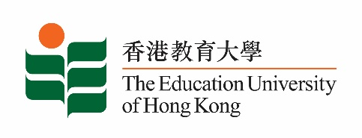
致： 传媒机构采访主任 23 February 2024
To : News Editors

香港教育大学2024年 2月26至 3月10日可供采访之活动一览
The Education University of Hong Kong (EdUHK) Events Calendar for 26 Feb – 10 Mar 2024
本校诚邀 贵机构派员采访下列活动。传媒查询，请联络教大传讯处（电话：2948 6050）。
You are cordially invited to cover the events below. For media enquiries, please contact the Communications Office at 2948 6050.

以下活动或有人数限制，传媒请预先向主办部门登记。
There may be restrictions on the number of participants for the following event(s). Please contact the respective organiser(s) / department(s) for prior registration.

- 教大大埔校园 （新界大埔露屏路十号） / EdUHK Tai Po Campus (10 Lo Ping Road, Tai Po, New Territories)

日期  Date | 时间  Time | 活动  Event | 地点  Venue |  | 主办部门及公众查询  Organiser &  Public Enquiry | 备注  Remarks
2024-02-26 | 8:30 am – 3:35 pm | UNESCO and UNEVOC (Hong Kong) Symposium: Empowering Youth  Skills for green innovation: fostering green transition to  a Sustainable Future | 教大大埔校园  EdUHK Tai Po Campus |  | 主办部门 / Organiser:  Department of International Education  国际教育学系  查询 / Enquiries:  Dr Aysuhan Tuba SARAL  Tel / 电话: 2948 8426 | 免费入场，  欢迎各界人士参加。Free admission.  All are welcome.
 |  |  | A-G/F-08  From 8:30 until 12:10 | C- L/P -02  From 13:35 until 15:35
日期  Date | 时间  Time | 活动  Event | 地点  Venue |  | 主办部门及公众查询  Organiser &  Public Enquiry | 备注  Remarks
2024-02-27 | 9 am – 4:30 pm | UNESCO and UNEVOC (Hong Kong) Symposium: Empowering Youth  Skills for green innovation: fostering green transition to  a Sustainable Future | 教大大埔校园  EdUHK Tai Po Campus |  | 主办部门 / Organiser:  Department of International Education  国际教育学系  查询 / Enquiries:  Dr Aysuhan Tuba SARAL  Tel / 电话: 2948 8426 | 免费入场，  欢迎各界人士参加。Free admission.  All are welcome.
 |  |  | A- 4/F – Council Chamber  From 9:00 until 12:00 | A – G/F - 08  From 13:00 until 16:30

